ASSIGNMENT-3

1) Retrieve the names and email addresses of all students.

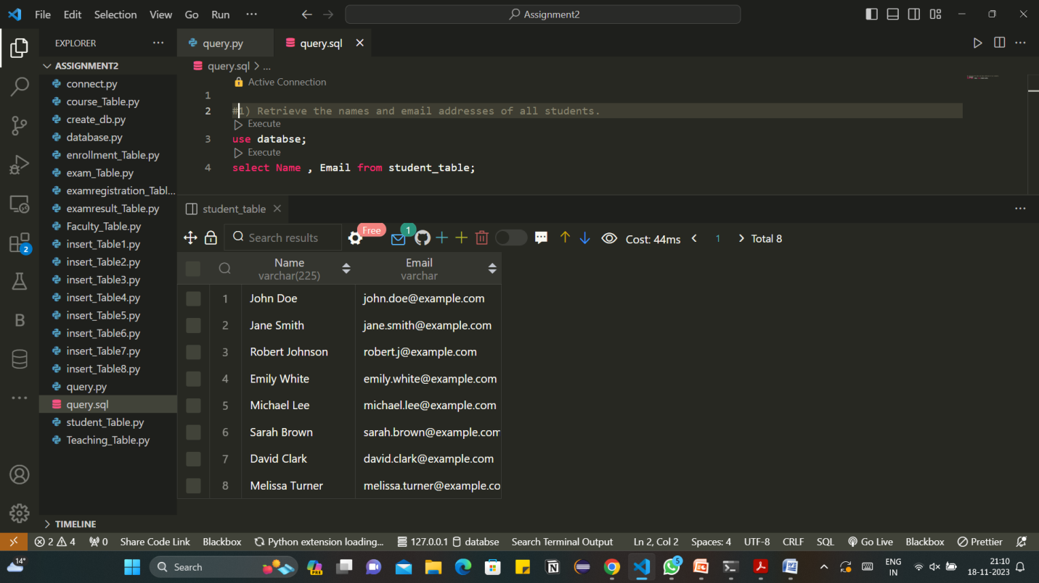

2) Find the courses that have more than three credits.

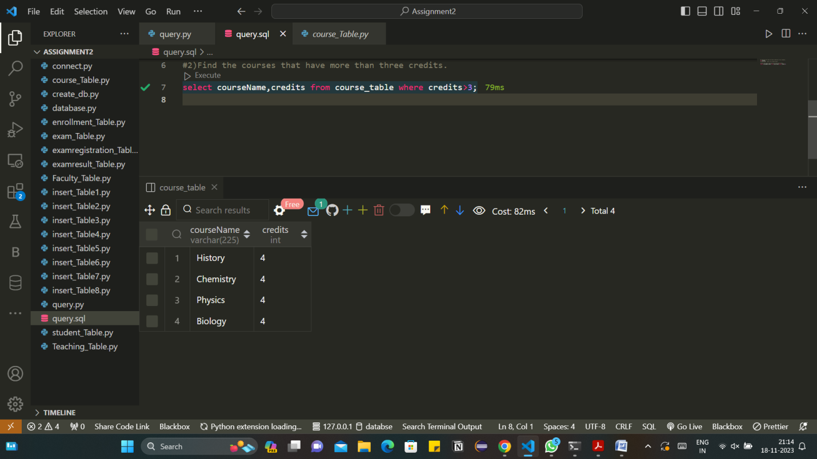

3) List the exams scheduled after November 15, 2023.

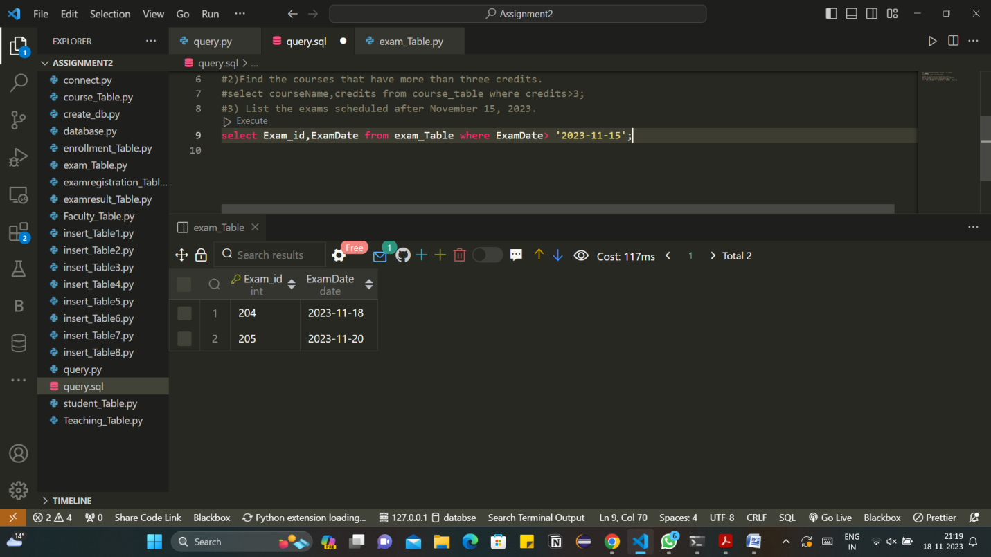

4) Get the faculty members who work in the "Mathematics" department.

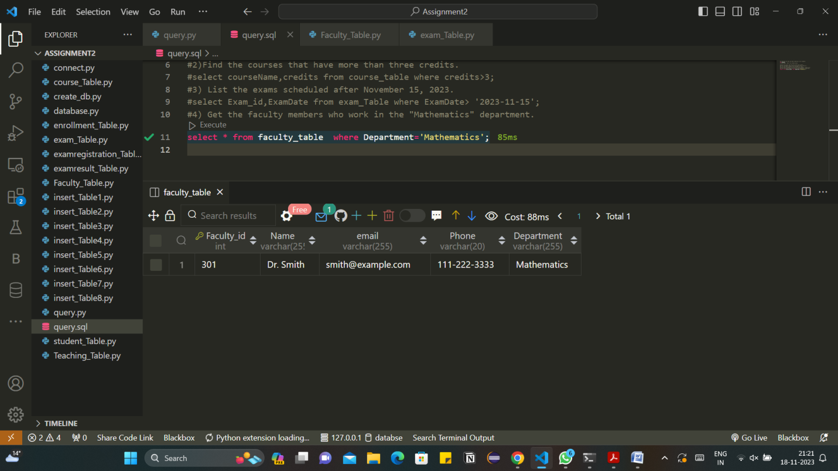

5) Retrieve the courses that each student is enrolled in.

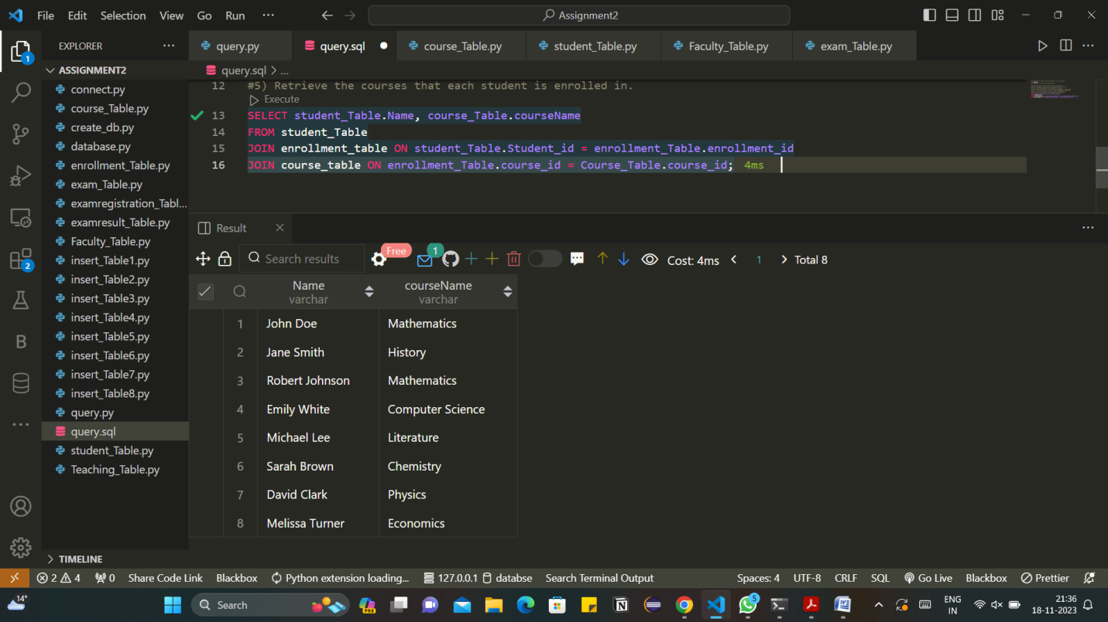

6) Find the average score for each exam.

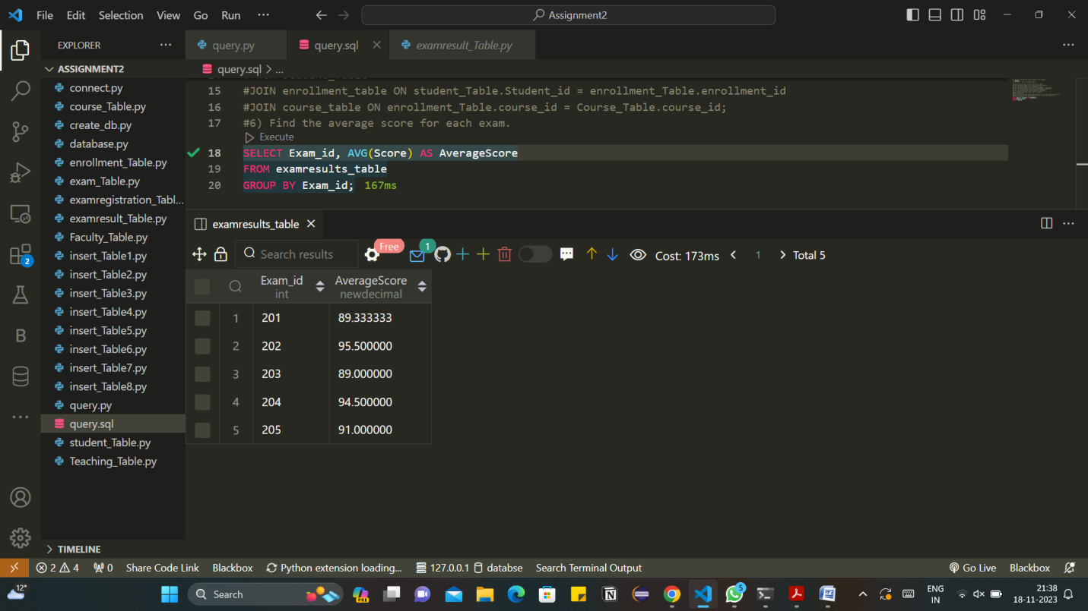

7) List the students who scored above 90 on any exam.

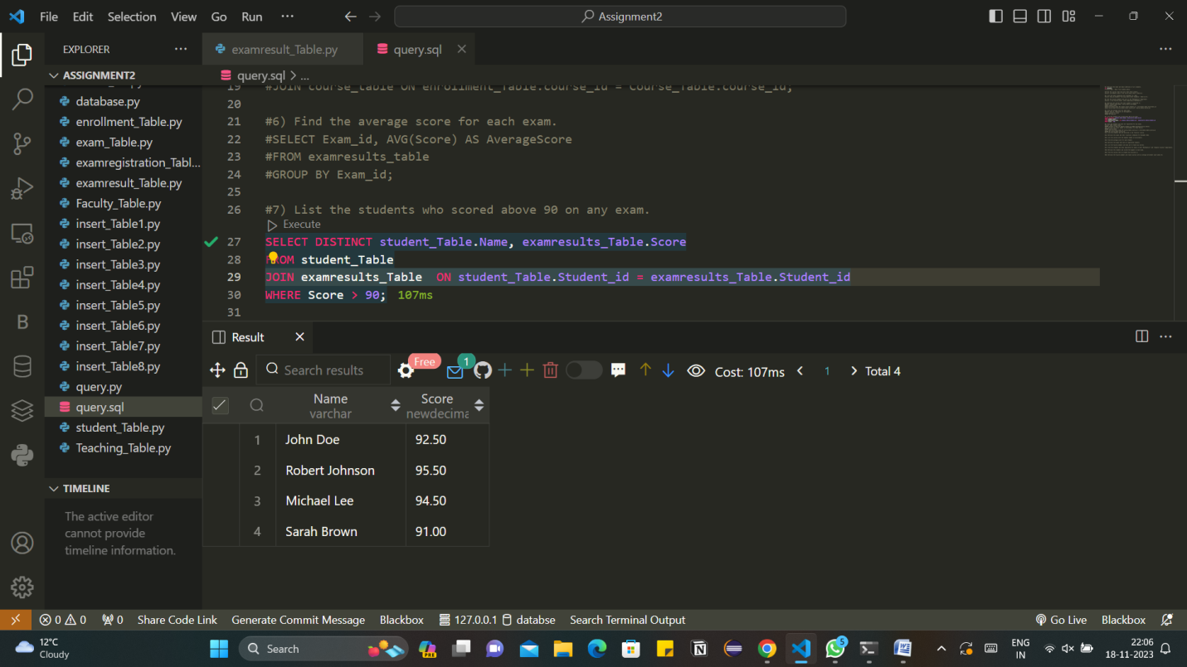

8) Retrieve the faculty members who teach multiple courses.

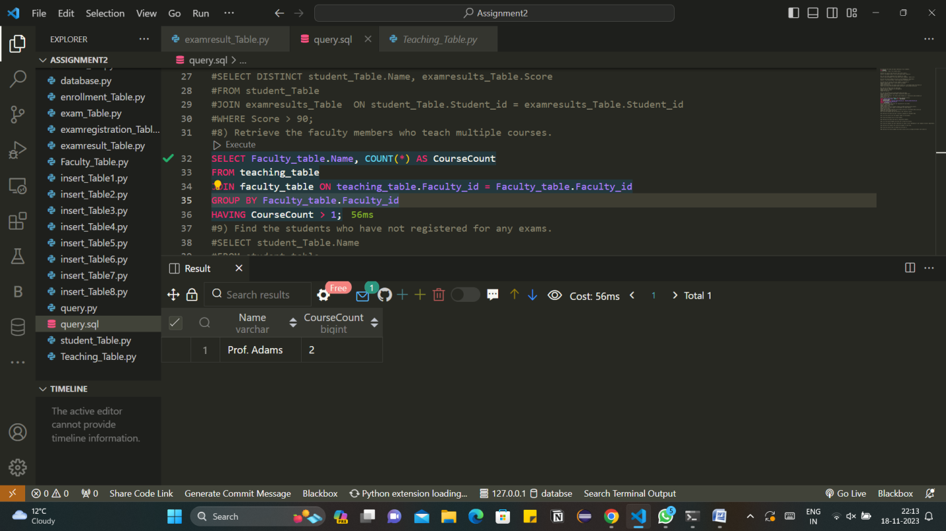

9) Find the students who have not registered for any exams.

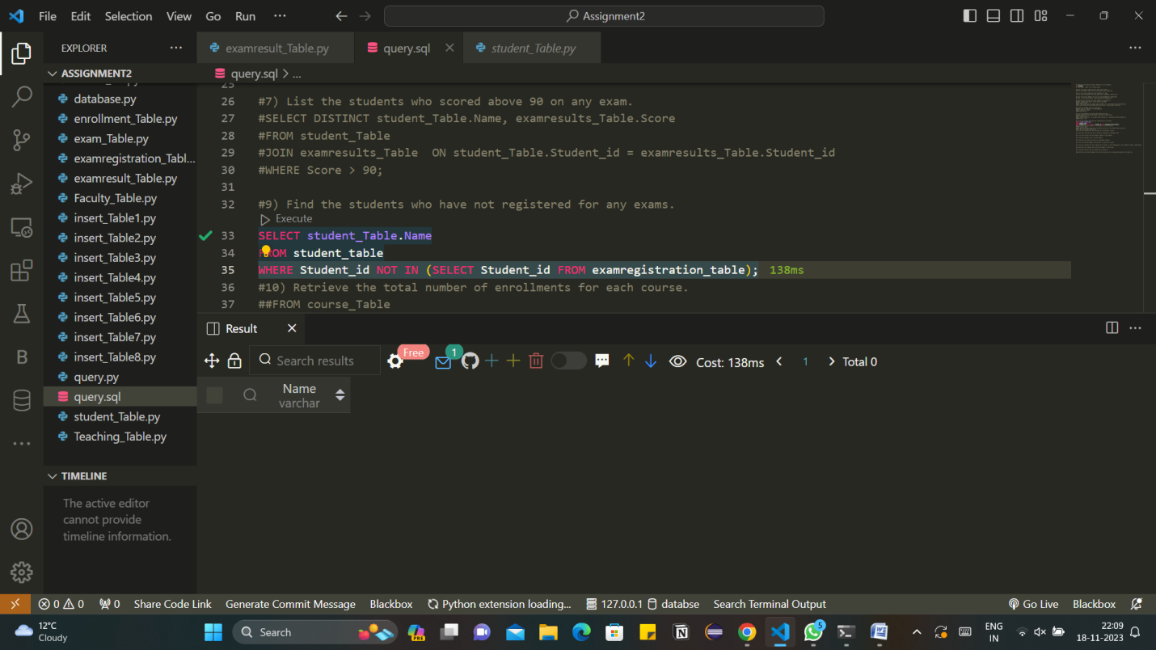

10) Retrieve the total number of enrollments for each course.

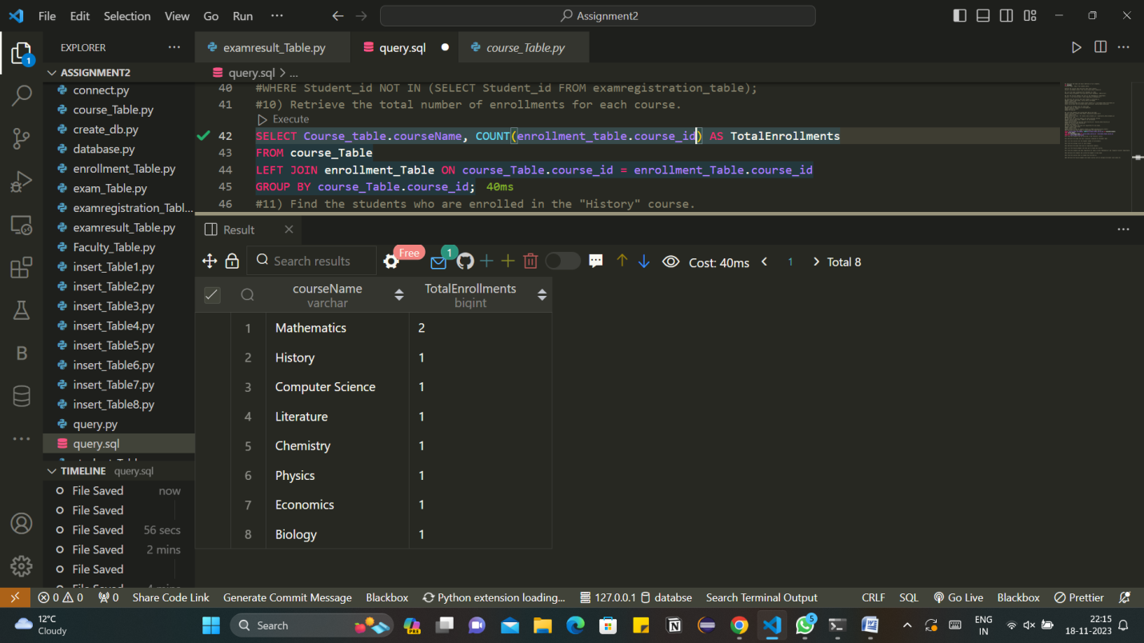

11) Find the students who are enrolled in the "History" course.

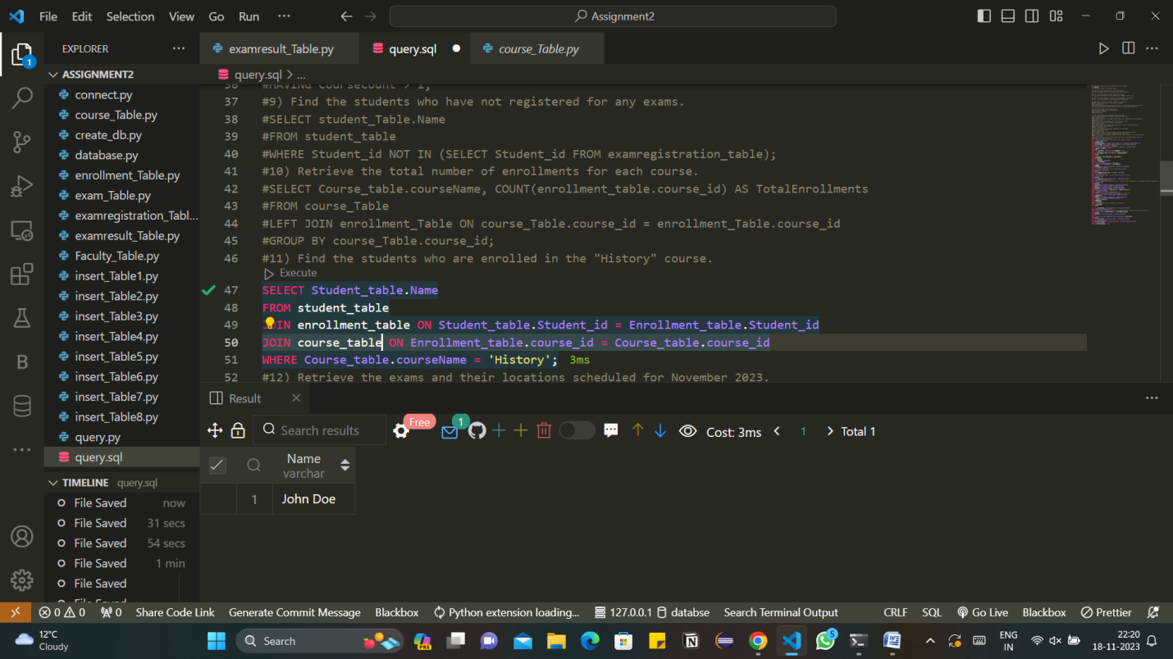

12) Retrieve the exams and their locations scheduled for November 2023.

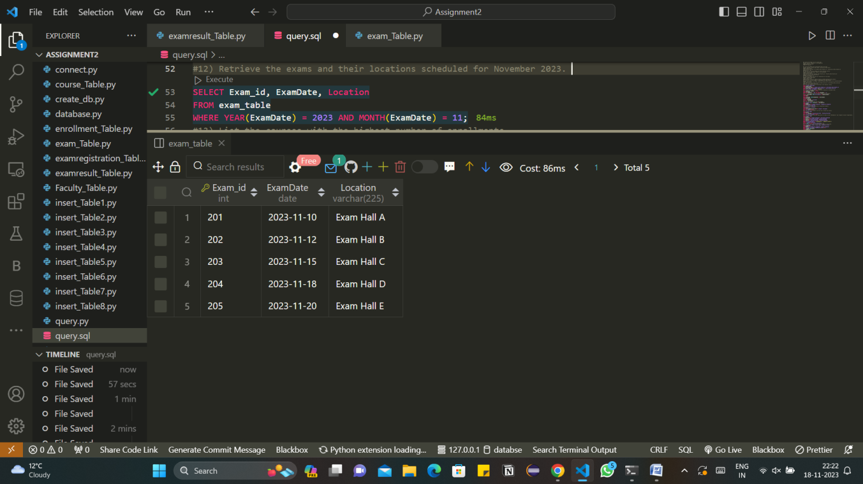

13) List the courses with the highest number of enrollments.

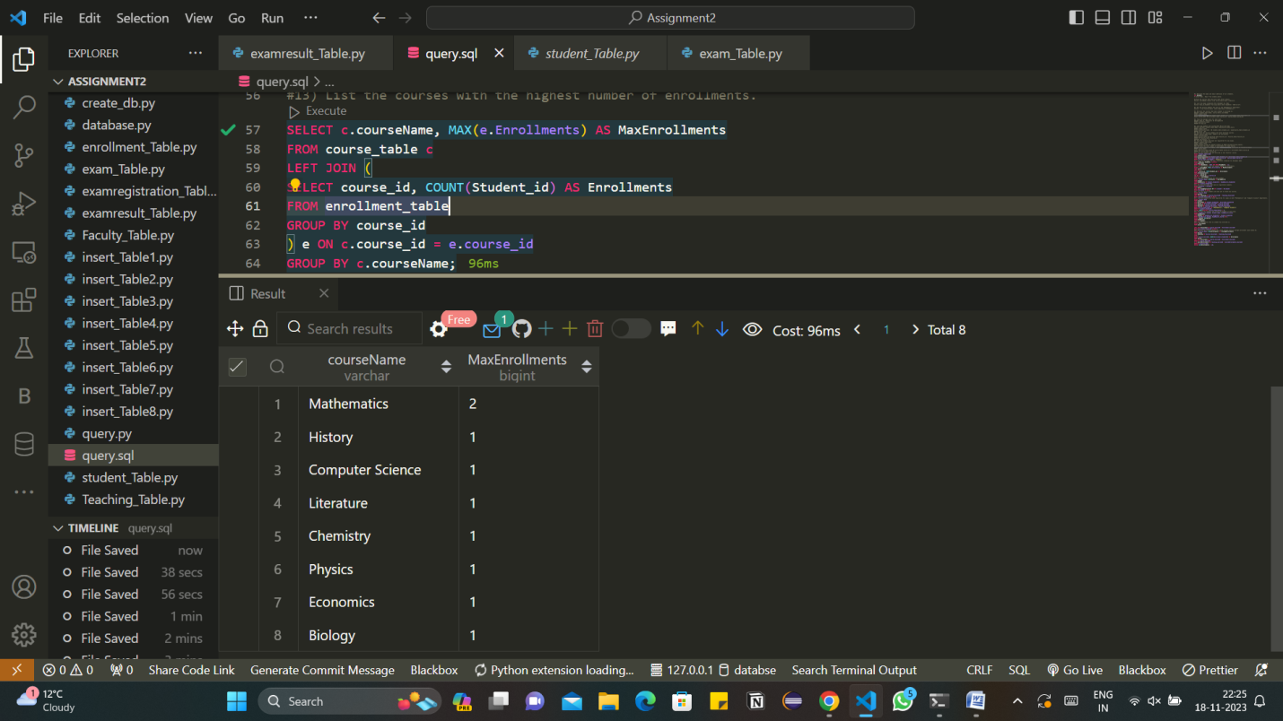

14) Find the average score for each student.

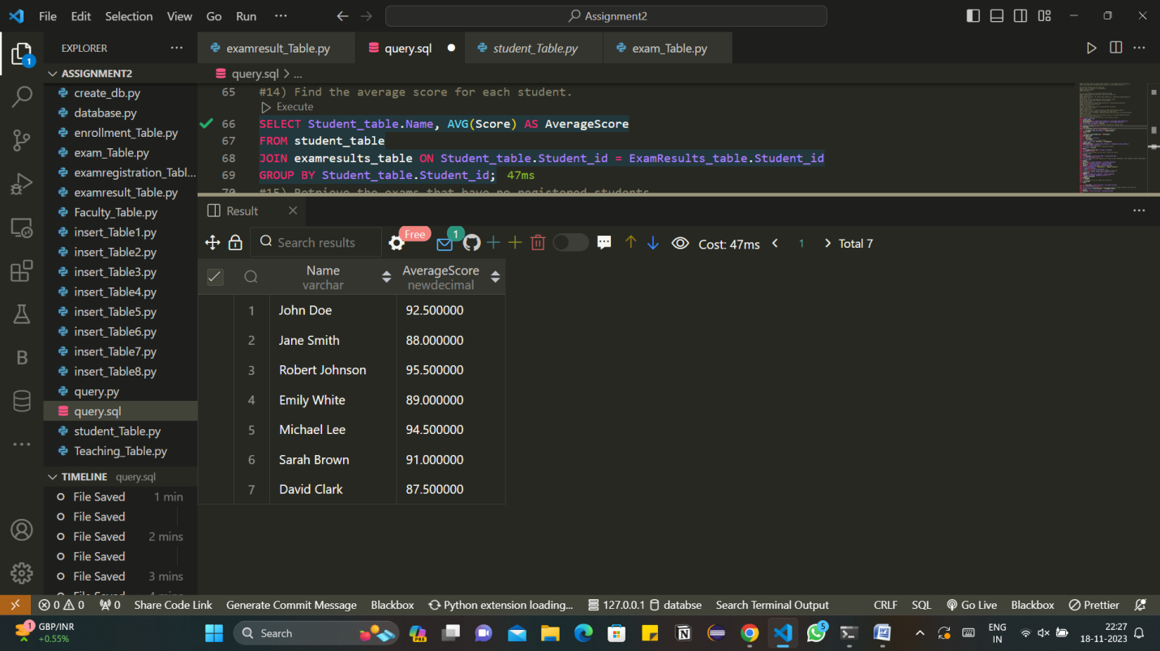

15) Retrieve the exams that have no registered students.

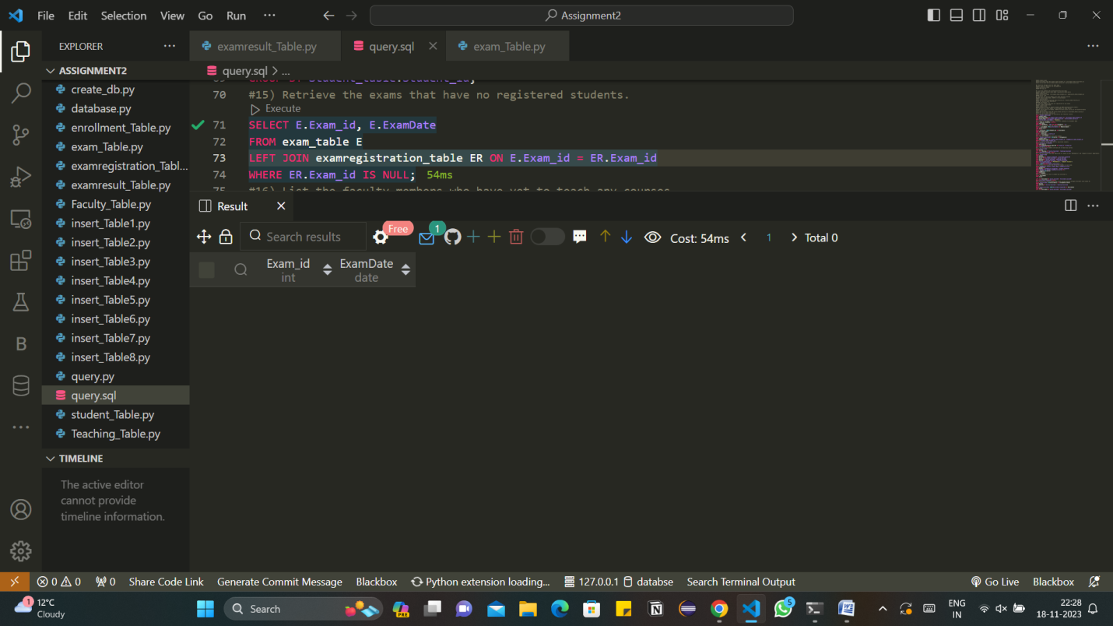

16) List the faculty members who have yet to teach any courses.

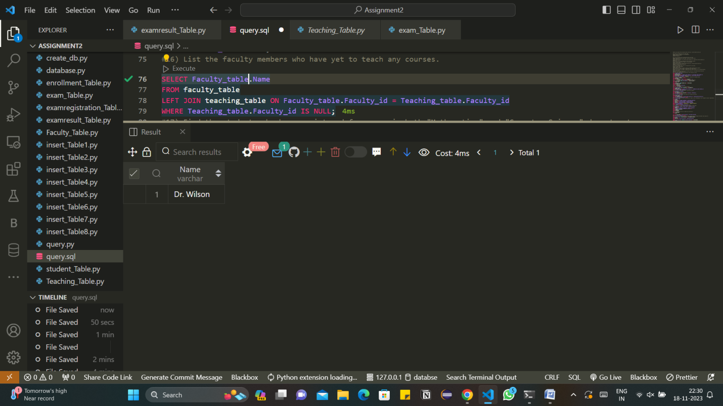

17) Find the students who have registered for exams in both "Mathematics" and "Computer Science" departments.

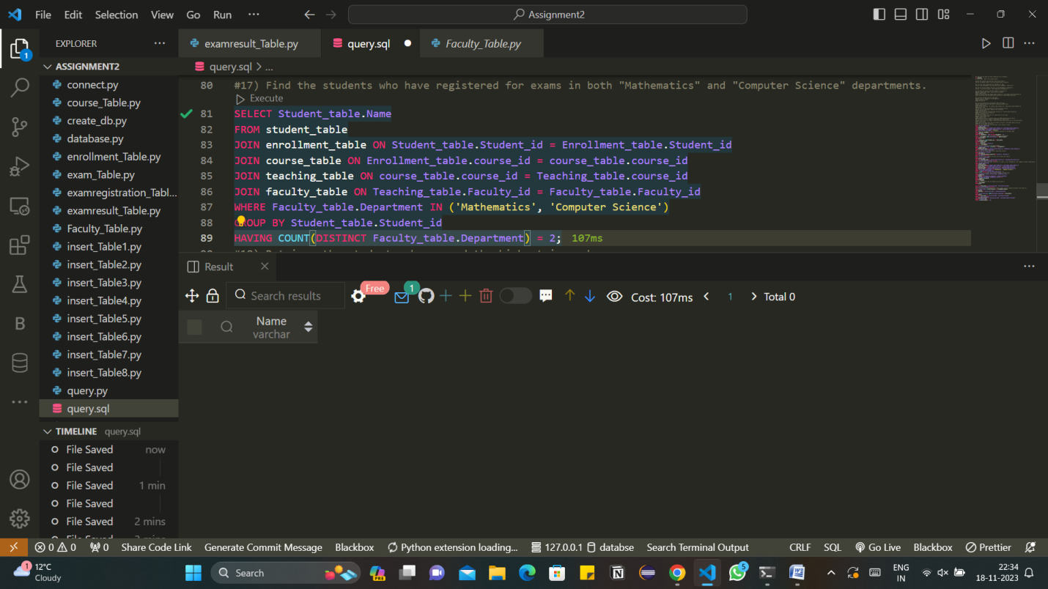

18) Retrieve the students who scored the highest in each exam.

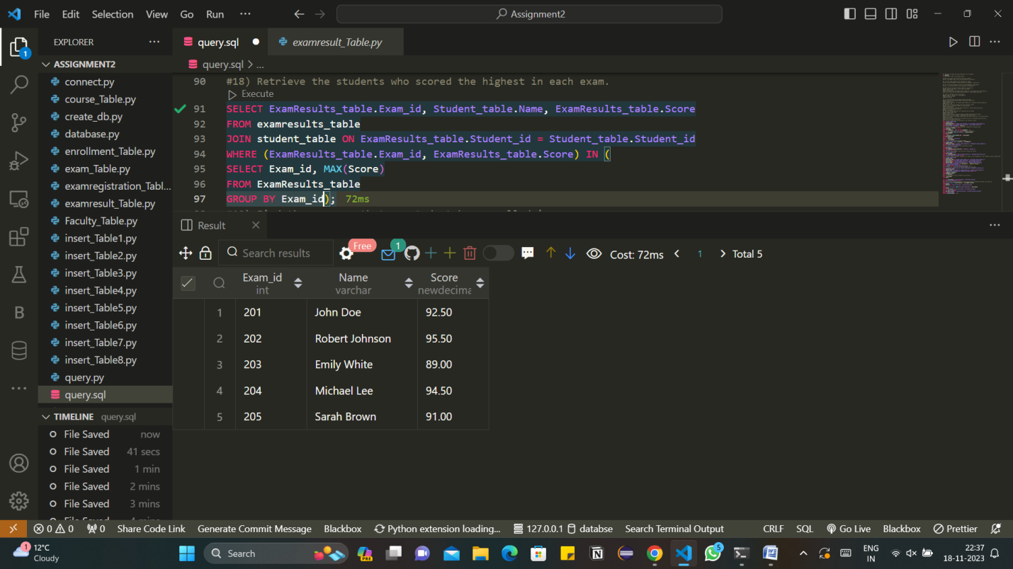

19) Find the courses that no student has enrolled in.

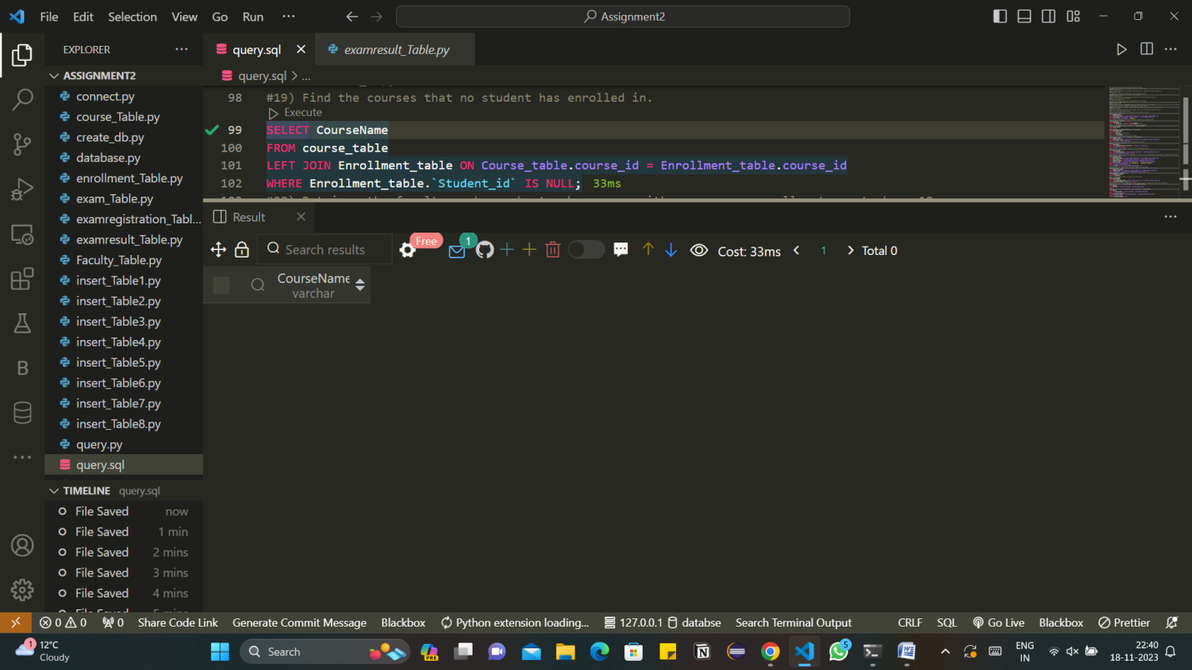

20) Retrieve the faculty members who teach courses with an average enrollment count above 10.

